TRAKSTAR TRAINING TUTORIAL
How to Log in and start your program
The Laser Training Institute of
Professional Medical Education Assn
www.LaserTraining.org
v2606
Once you have registered for one of our online Laser Training programs, you'll receive an email with a link that takes you to the Trakstar (previously called Mindflash) website with your "Course Dashboard" to get started. It's intuitive and straightforward, so don't make it any more complicated than it is. It's very simple but you must read the instructions and prompts in the program. Most people don't even need this set of instructions because it's so intuitive, but if you have problems then read this through.
In a nutshell .... You go to the Trakstar login page and create your own password. We have no access to that and cannot set it up for you. If you forget, there is a link to click about "forgetting your password" on the login page. That sends the password back to your email (not to us).
Here I'll show you a screenshot of the login process for one of our Course Series that involves many different modules. Some of our shorter courses have only one module so the process is the same but much simpler since it's only the one-course module.
GETTING EMAILS ..... Some of your emails will come from our office directly including me (Gregory Absten), and some will be automated emails coming from the Trakstar system that simply has my name on them. POTENTIAL ISSUE - if you're not getting the welcome emails check your SPAM folder. Unblock those from lasertraining.org AND the Trakstar system.
ACCESS YOUR PROGRAM 24x7 from anywhere in the world with a reliable internet connection. It is accessible from both Windows and MAC systems any time of the day, any day of the week. If for some reason you have a very bad internet connection, you will probably have a hard time accessing and loading the programs. It's your connection most of the time, and not the online program itself. You can check your ping times and your upload and download rates at www.speedtest.net. If your connection is not good, you'll have to work that out with your internet provider. We can't help with that end of things.
Large companies or Hospitals sometimes block access to the trakstar types of sites (flash players). If this occurs, you'll either need your I.T. Dept to bypass their lock for you (it's easy) to access it, or alternatively you'll need to access the program from your home or other computer connection.
STEP ONE - RECEIVING YOUR INVITATION EMAIL FROM TRAKSTAR ....
Here's the automated email you'll receive from TRAKSTAR once you're set up. It has my name on it but I never see these as they go out:
*********************

From: Professional Medical Education Assoc.
Hi Gregory,
You have been enrolled in the following series of online courses, Aesthetic Laser & Light Based Procedures v14. Please click on the links below to begin. This series is required to be taken in the order shown below:
Aesthetic Laser I, part 1 v14:
https://sso.m-ft.co/v64m6q6-0
Aesthetic Laser 1, Part 2 v14
Aesthetic Laser II, Part 1 v14
Aesthetic Laser II, Part 2 v14
Aesthetic Laser III v14
Aesthetic Laser IV, Part 1 v14
Aesthetic Laser IV, Part 2 v14
Aesthetic Laser V, Part 1 v14
Aesthetic Laser V, Part 2 v14
Aesthetic Laser V, Part 3 v14
Aesthetic Laser VI, Part 1 v14
Aesthetic Laser VI, Part 2 v14
Aesthetic Laser VII v14
Aesthetic Laser VIII, Part 1 v14
Aesthetic Laser VIII, Part 2 v14
Aesthetic Laser IX v14
Aesthetic Laser X, Part 1 v14
Aesthetic Laser X, Part 2 v14
Aesthetic Laser XI v14
Aesthetic Laser XII v14
Thanks, Gregory Absten

Easy Online Training
www.mindflash.com
((Notice in this older graphic above they use the word “Mindflash” and old URL. It is now “Trakstar” and the URL is www.trakstar.com).
NOTE THAT THE LOGIN PAGE FOR OUR LASER COURSES IS:
https://lasertraining.learn.trakstar.com/
***********************************
Notice that in the course above there are a series of modules to be completed. Only the first module has an active link because you must complete them one by one before it will let you advance. When you complete the prior one and go back to your course dashboard on their website, the link will be active for the next course.
STEP 2 - FOLLOW THE LINK TO YOUR COURSE DASHBOARD and create your own Password.....
Click on the link that is provided to you in your invitation email to go to the login page.
(ALTERNATELY - If you trash or lose that email you can access it directly from the front page of our LaserTraining.org website by clicking on the "Mindflash Course Login" link toward the top left of the front page. Or ... that login page is located at https://lasertraining.learn.trakstar.com/.
When you follow the link you'll see this first time login page:
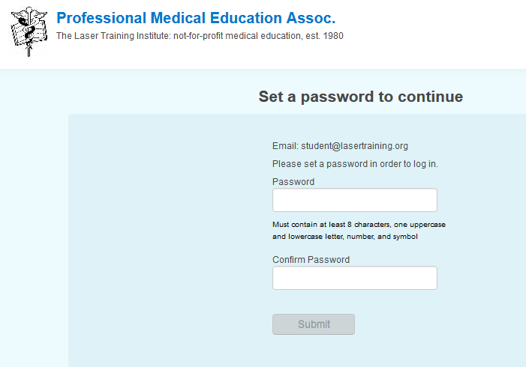
Go ahead and create your own password. We have no access to it and cannot set it for you nor retrieve it for you. If you forget it later there is a button to click to have it resent to you from the system. Their password rule is stated clearly on that page. It must have at least 8 characters, including one uppercase and lowercase letter, a number, and symbol – or whatever they state in the future.
OK ....... I created a password and click "submit".
This immediately takes me to the first page of my first module in the course series, the example in the Aesthetic Series shown here:
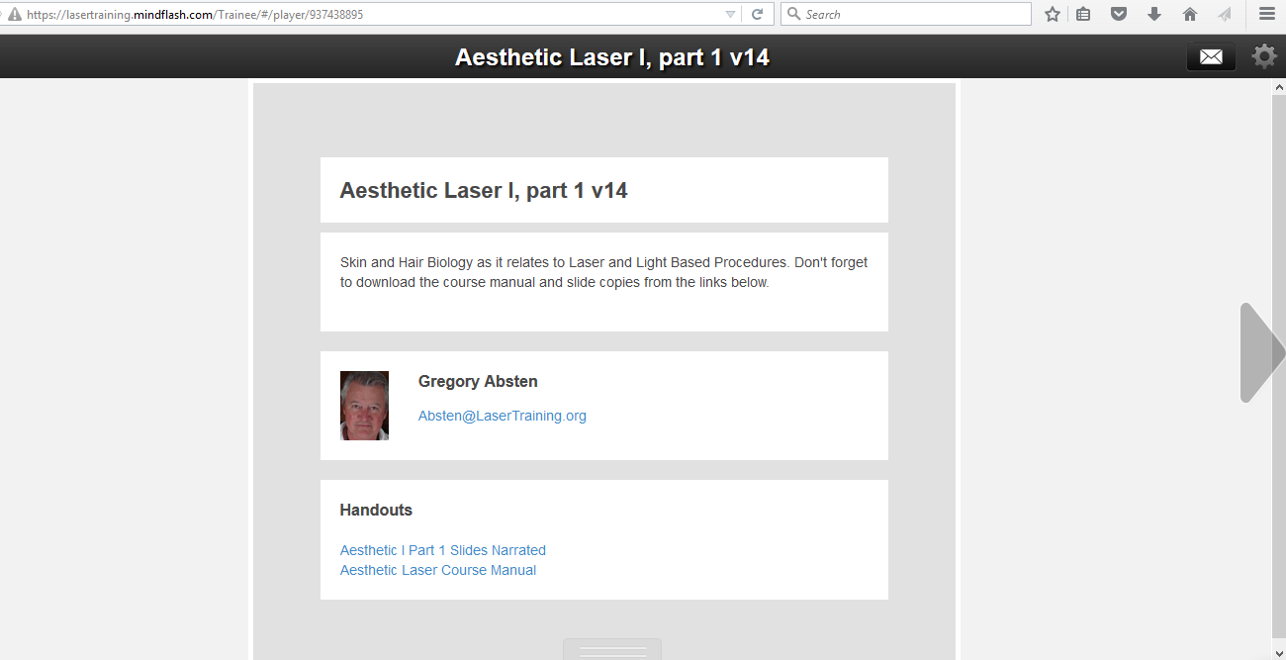
IMPORTANT: Notice the bottom of this first slide has "handouts". These are the PDF files for the printed slides and course manual. You MUST download them from the beginning here. After you finish a module you can't go backwards to get them. Just save them on your computer somewhere and then at your option print them or just read them on your computer. That stays with you. Watch for these types of downloads periodically during the course. THOSE DOWNLOADS ARE NOT HOW YOU TAKE THE COURSE HOWEVER – They are there for you to keep yourself. You must take the course online by clicking the arrows to go slide by slide. That’s the only way the system knows you completed it and then issues an accredited certificate at the end.
Notice the arrow on the right hand side. This is how you advance to the next slide. Most (but not all) of the slides have audio narration so let it play through until you advance to the next slide. Some of these are short instructional videos.
STEP 3 - LOGGING OUT:
When you’re ready to quit (even part way through a module, just click on the icon in the top right of the slide as shown here:
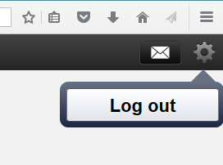
When you come back the program will remember where you were.
If you have a question as you go along just click on the envelope icon to the left of the logout icon and you can send me an email (me personally - not automated). A screen will pop up to allow you to send the email.
STEP 4 - LOGGING BACK IN .....
If you still have the original invitation email and link just use that.
Or ......... enter the URL directly as https://lasertraining.learn.trakstar.com/
Or ......... Go to our www.LaserTraining.org website and click on the "Trakstar Course Login" link toward the top left of the page. The screenshot of this login page is:
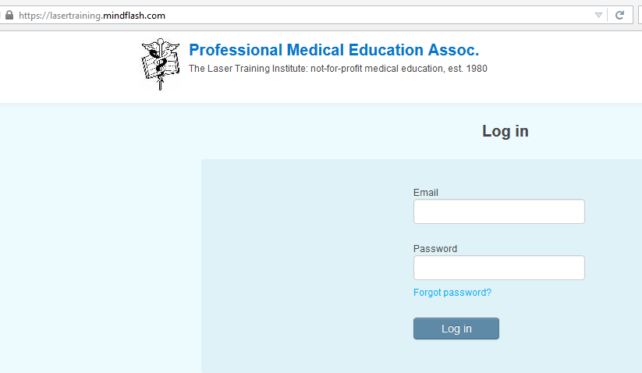
Notice that you now must enter your EMAIL AND PASSWORD that you created previously. Use the email address that you registered with. Use the Password that you created the first time you logged in to the Trakstar system. Notice the "Forgot Password" link ...... if you forget just click this link and the system will send it back to your email address. We have no access to that.
In the example here of the Aesthetic Laser series, it takes me back to where I left off:
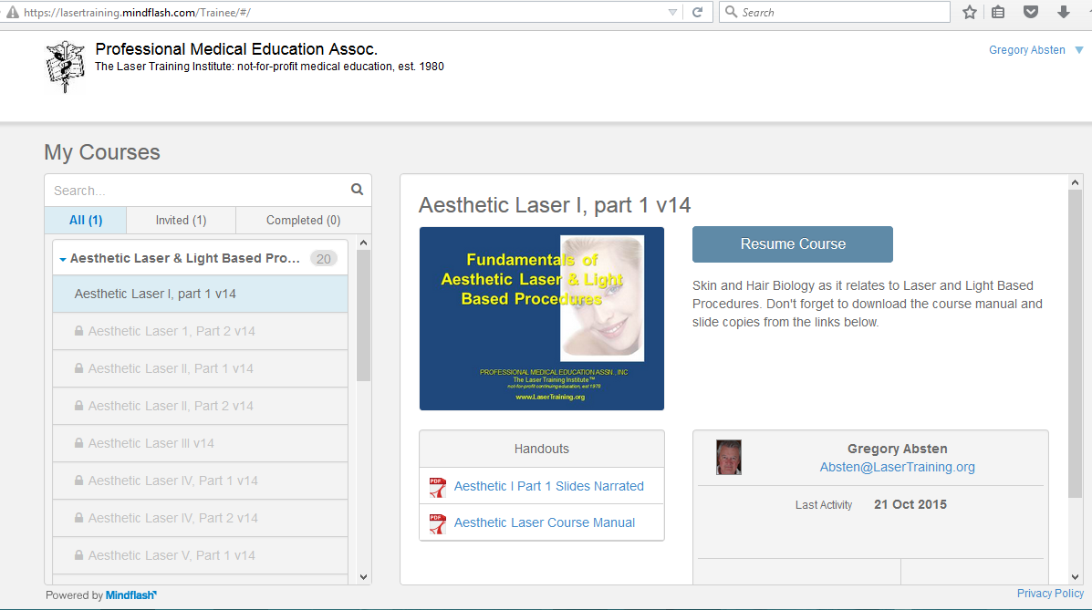
Since I had not yet finished module I, I can still download the handouts, but when I finish this module, I can't go back and do this. Just click on the "Resume Course" to pick up where you left off. That takes me to the last slide where I quit.
ACCESS YOUR COURSE ROUTINELY TO COMPLETE IT:
We have only so many "seats" available at any one time in our online courses. For that reason, if someone is registered but sits for weeks or months without accessing it, it ties up our available spots to register new students. We set time limits on some of our programs - very conservatively at 17 weeks total time to complete (most of these can be completed in just a few days to a week). After that time, you will have to pay a re-instatement fee to continue the course. Many of our courses however have no such time limit on them yet. However, if you don't access your program at least once every 30 days you will be "archived" and no longer be able to access your program until you call or email to be re-activated. Please just make steady progress on your program. That's most helpful to you as well to get the most out of the training and retain what is being taught.
QUIZZES AT ENDS OF MOST MODULES:
Most modules have a quiz you must take and pass. For that reason, don't rush through a module just browsing it. Take the time to read and listen to each slide. You'll be tested on it. You must have a 70% or better to pass. If for some reason you don't pass a module you can reset it yourself by going back to your course dashboard, select that course module, then scroll down until you see “reset” to click it (not “review”). That lets you start again. If you have issues just let us know and we'll reset you at no charge for that module.

FINISHING THE COURSE AND RECEIVING YOUR ACCREDITED CERTIFICATE OF LASER TRAINING:
When you finish your last module you'll receive an automated congratulations email that will also contain a link to download your accredited Certificate of Training as a PDF file. Once you complete the program you cannot go back to take it again, but you do have your downloaded slides and manual.
Some of our courses (such as Aesthetic or Laser Hair Removal) will automatically enroll you in an NCLC practice certification exam after you’ve completed your course. You already have your training certificate, but laser certifications are a separate step. You do not need to complete this practice exam if you don’t want, but if you plan on taking one of the NCLC Laser Certification exams this will be MOST helpful. That practice exam is good for 45 days to take as many times as you like for the practice. It self grades as you go along so you know how you did. If you decide not to take it the email reminders will go away after 45 days.
For more information on the Certifications go to https://LaserCertification.org. When you obtain a Laser Certification you will be listed on the International Laser Certification Registry (ILCR™) at https://LaserRegistry.org.
Some of our students are part of various training groups around the world that use our learning platform. Some of those groups appoint a “Reporter” who has access to all these online records to check on progress and be able to download copies of certificates for students if needed later. If you are an Affiliate or Associate of the NCLC utilizing our training institute’s online courses and would like to appoint a “Reporter” to monitor your student’s online activity, please contact Gregory Absten. We do this at no charge to setup Reporter status for any groups utilizing our programs.

QUESTIONS?
Email Gregory Absten: Absten@LaserTraining.org
Call the office at 01.614.883.1739 or 800.342.2704 from within the U.S.
https://LaserTraining.org
https://LaserCertification.org
https://LaserRegistry.org
https://www.youtube.com/@lasertraining/videos (laser training videos)

